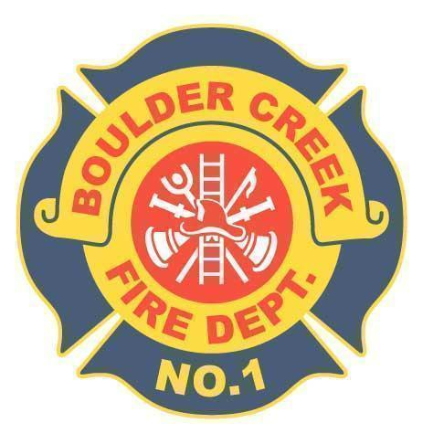

**BOULDER CREEK FIRE PROTECTION DISTRICT**

**13230 Central Avenue, Boulder Creek CA 95006 · Office: (831) 338-7222 · Fax: (831) 338-7226**

Board of Directors

Minutes of the Board of Directors Meeting

Special Board Meeting

October 22nd, 2024

1.0 Convene Meeting/Roll Call

* The Special Board meeting of the Board of Directors of the Boulder Creek Fire Protection District was called to order by Chairman Locatelli on October 22nd 2024 at 9:00 A.M. Present were Director Currier, Director Locatelli, Director Robustelli, Director Presswood, Director Scruggs, Fire Chief Bingham and Admin Aileigh McCormack. No Public Member was present.

2.0 Additions and Deletions to Agenda

* None

3.0 Oral Communications

* None

4.0 To review purchase options for new fire apparatus and discuss joining CSDA California Special Districts Association. Possible action by board

.01 Review purchase options for new fire apparatus

* Provided are two options on purchasing the new Type 1 Engine provided by Golden State Fire Apparatus. Option A 100% Pre-Payment or Option B Payment at time of delivery.
* Dir. Scruggs is concerned about price changes throughout the timeline of the build and what the contract language states regarding those changes.
* Golden State Fire Apparatus’s contract states we will be given notice fourteen months prior to the completion of the Engine, there will be an estimated total given and the option to cancel the contract. A cancellation fee would be assessed.
* Chief Bingham stated that there is a four year wait on receiving the engine after signing the contract.
* Chief Bingham provided materials from other California fire agencies regarding moving reserve funds to investments. Examples of a Reserve Policy and Investment Policy were handed out
* Chief Bingham was directed to schedule a California CLASS representative to come speak at the next board meetings regarding special district investing.
* Dir. Presswood contacted a financial consultant from Morgan Stanley on behalf of the budget sub-committee. He was advised not to pay upfront and to consider investing funds due to the 4 years the fire engine takes to build and receive.
* Motion made by Dir. Robustelli, to purchase the Type 1 Engine presented to the board under Option B, payment upon arrival at the price $1,122,183.25 of seconded by Dir. Presswood. Vote was unanimous. Motion carries.

.02 California Special Districts Association membership

* Dir. Scruggs provided additional information on joining the CSDA.
* The joining cost would be $4,095 annually but if we join before October 31st, the next two months are free.
* There are required classes the board has to take and CSDA offers.
* Dir Scruggs is interested in the online knowledge databases, California CLASS, discounts, PERS advice and information, etc.
* Motion made by Dir. Scruggs, to instruct Chief Bingham to join the CSDA for one year as a trial and the funds will be taken from Special District Expenses, seconded by Dir. Presswood. Vote was unanimous. Motion carries.

5.0 Adjournment at 10:25 A.M.